EXPERIMENT NO: 13
Determination and plotting of intinsic impedance and phase velocity of various medium Aim:
To determine and plot intrinsic impedance and phase velocity of various medium. Software required:
• SCILAB version 6.0.1 Program:
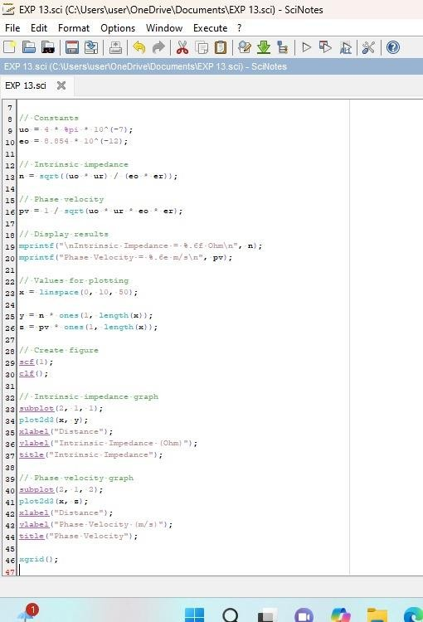

Output:
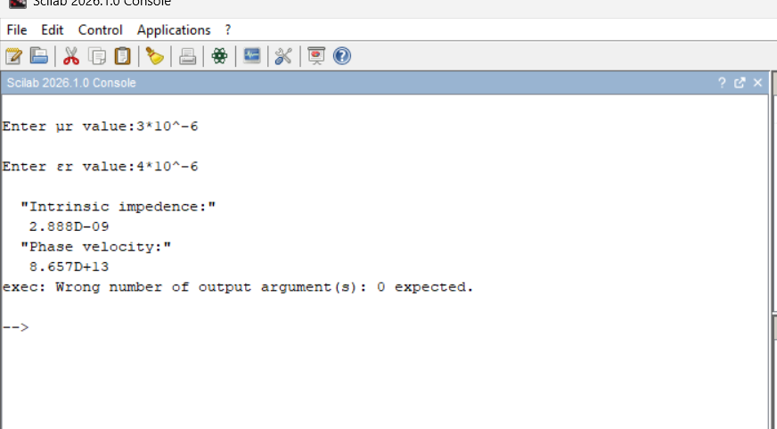

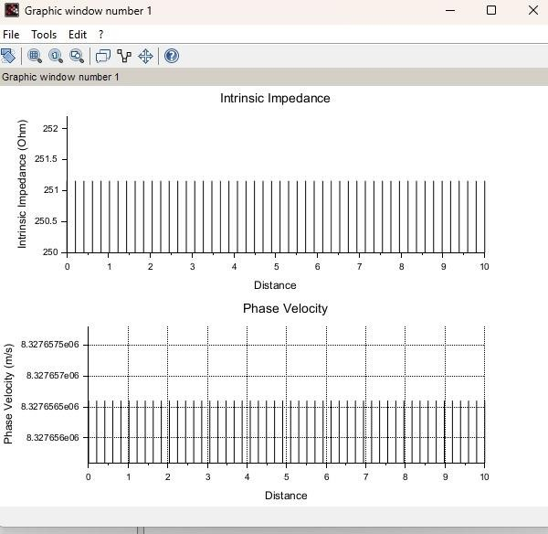

Theoretical calculation:

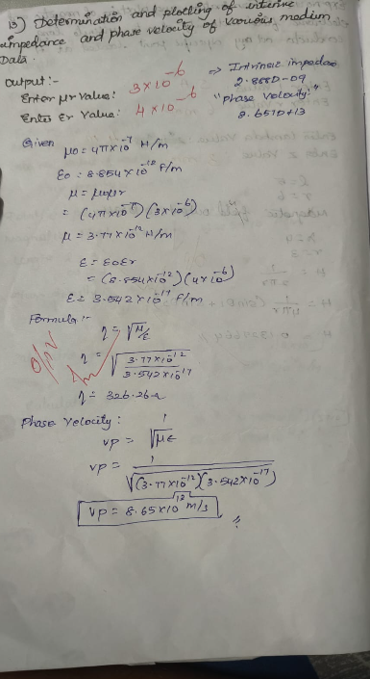

To determine the intrinsic impedance and phase velocity of electromagnetic waves in free space(vacuum).
Program:
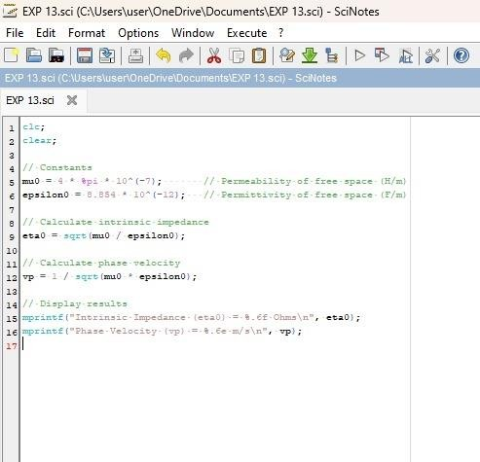

Output :
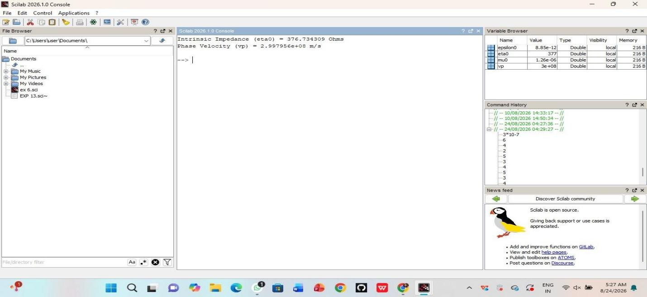
To determine the intrinsic impedance and phase velocity for a wave propagating through a conductive medium like copper.
Program:
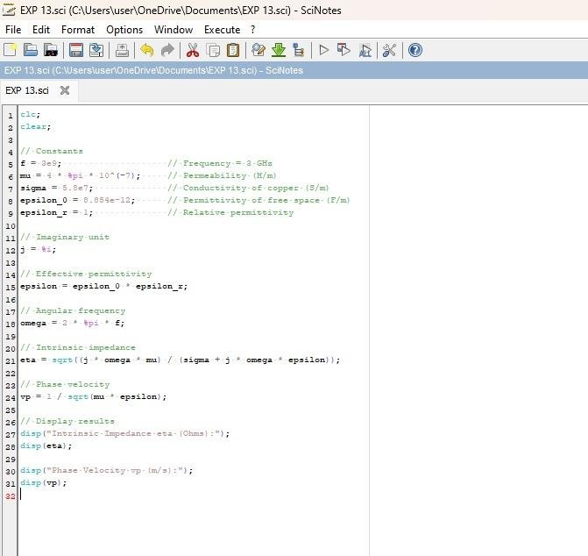

Output :
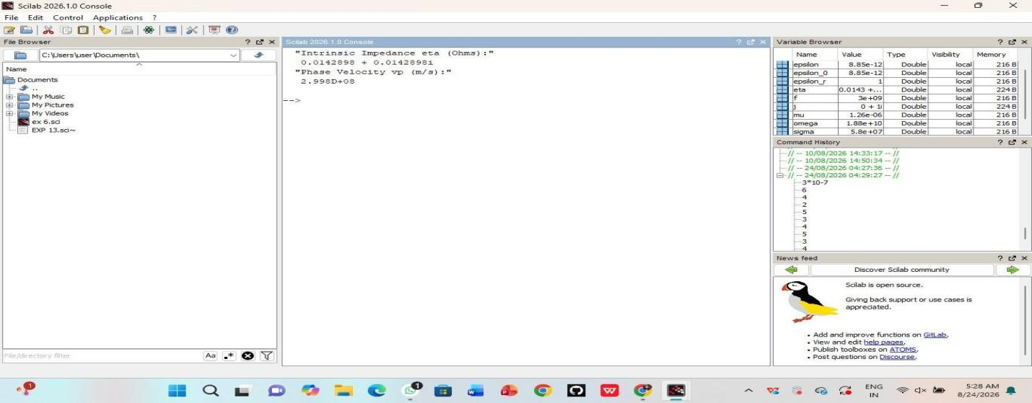
To determine and compare the intrinsic impedance and phase velocity of electromagnetic waves propagating through different media: Vacuum, Air, and Water.
Program:
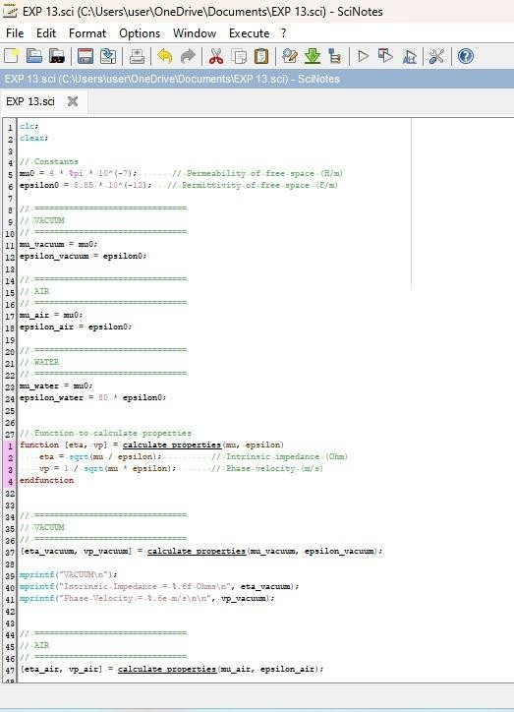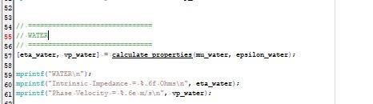

Output:

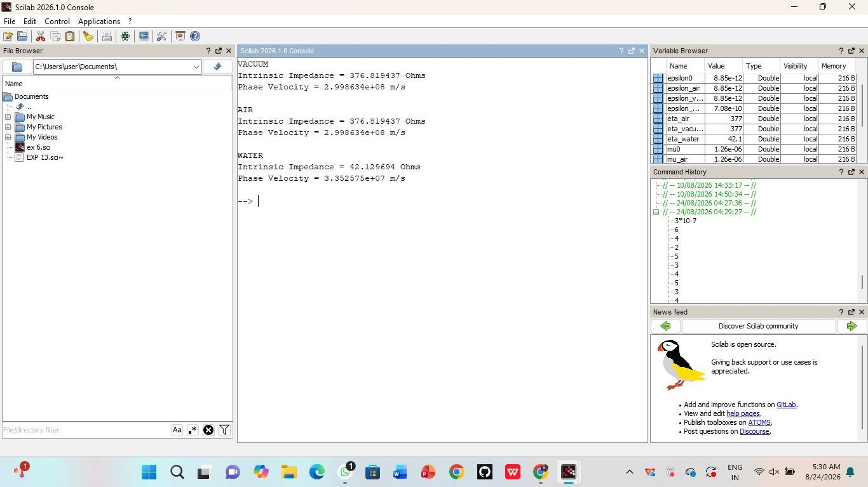

Result:
Thus the determination and plotting of intrinsic and phase velocity is performed and successfully verified in copper.

